Sr. N  o. | Name | Designation | Dept. | DOB | DOJ | E-mail & Mobile No. | Regd.No | Teacher Code: | Qualifica tion | Exp  erie nce | Photograph
1 | Dr Rajesh C K | Professor and  Principal | Dravyaguna | 01/02/1978 | 02/08/2025 | drrajeshck79@gmail.com, 9747711456 | GB I - 25214 | AYDG00359 | MD  Dravyagu na | 11 yr 4 Month & 13 days | 
2 | Dr.M. Gautham | Associate Professor | Dept. of Samhita Siddhanta & Sanskrit | 18-12-1988 | 11/09/2025 | manasaarogyapatrika@gmail.com  8019413217 | KAUPB No.43385 | AYSS01279 | MD  Samhita | 5 years, 11 Months, 18 days | 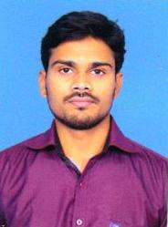
3 | Dr Akhil C. | Assistant Professor | Dept. of Samhita Siddhanta & Sanskrit | 25th May 1986 | 26/12/2024 | akhilc002@g mail.com 9447415385 | TCMC 11448 | AYSS02125 | MD, PhD  Samhita. | 4 years 1month  5 Days | 
4 | Dr Anjana S. | Assistant Professor | Dept. of Samhita Siddhanta & Sanskrit | 22nd July 1987 | 07/01/2025 | anjana.chithra layam @gmail.com 9656170437 | TCMC 26358 | AYSS 01797 | MD  Samhita. | 3 years 29 days | 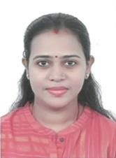
5 | Ms. Kaminiben Jayantibhai Patel | Assistant Professor (Sanskrit) | Dept. of Samhita Siddhanta  & Sanskrit | 16th Oct 1978 | 09/06/2022 | kaminip091@ gmail.com 9316705189 | N/A | AYSN 00551 | MA  (Sanskrit) | 3.6 years | 
6 | Dr. Yedhu Krishnan T.B | Associate Professor | Rachana Sharira | 6th Nov 1988 | 04/06/2024 | dryedhukrishn antb@gmail.c om 9496025251 | TCMC  12714 | AYRS 00833 | MD  Rachana Sharira | 9 Year and 18 Days | 
7 | Dr. Sreekanth Vaidyanath R S | Assistant Professor | Rachana Sharira | 27TH JUNE 1995 | 22/09/2025 | sreekanthvaidyanath@gmail.com  8073008544 | KAUP.39169 | AYRS 01321 | MD  Rachana Sharira | 3 years 1month and 29 days | 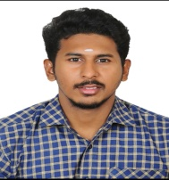
8 | Dr.Sreelekshmi G | Associate Professor | Kriya Sharira | 11th september 1984 | 21/07/2025 | lekshmi.bams@gmail.com  9995691000 | 11041 | AYKS00266 | MD  Kriya Shareera | 8 years 10months | 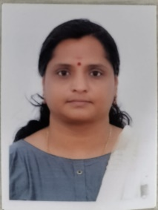
9 | Dr. Komal A. Chavda | Assistant Professor | Kriya Sharira | 12th August 1995 | 02/06/2025 | drshreeji96@gmail.com 8758382686 | GB I - 21912 | AYKS01379 | MD  Kriya Shareera | 7month 29 day | 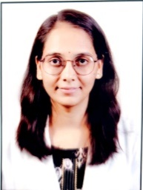
10 | Dr Pinalben Neel Vihol | Assistant Professor | Dravyaguna | 4th Dec 1992 | 01/12/2023 | 412pinalchav da@gmail.co m 9722562403 | GB I  20571 | AYDG 01848 | MD  Dravyagu na | 2 years 2 month 7 days | 
11 | Dr. Suchithra P Bai. | Assistant Professor | Roga  Nidan Evam Vikriti Vigyan | 25th Oct 1992 | 11/01/2025 | suchithra9223 @gmail.com 9446404059 | TCMC  18177 | AYRN01237 | MD  Rog Nidan | 1 year 21 days | 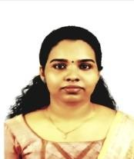
12 | Dr. Ketan Ramanlal Rathava | Associate Professor | Rasashastra Bhaisajya Kalpana | 9th April 1992 | 03/01/2024 | ketan4849@g mail.com 9427789065 | GB I  20224 | AYRB 00600 | MD  Rasa Shastra & Bhaisajya  Kalpana. | 7 Year 1 month 5 days | 

13 | Dr. Dipaliben Dilipkumar Patel | Assistant Professor | Rasashastra Bhaisajya Kalpana | 17th july 1998 | 08/09/2025 | Dipalipatel1856@gmail.com 9265169640 | GB I  23587 | AYRB02290 | MD  Rasa Shastra & Bhaisajya Kalpana | 4 months 23 days | 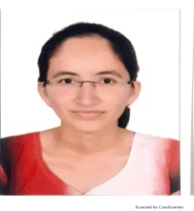
14 | DrArjun CheruKattil Muraleedhran | Associate Professor | Swasthavritt a Evam Yoga | 14th Nov 1989 | 09/08/2024 | cherukattilarj un@gmail.co m 9745557546 | TCMC  13761 | AYSV 00037 | MD  Swastha Vritta | 06 Years /06 Months /06 Days | 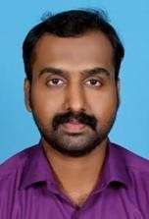
15 | Dr. Jayalakshmi S | Assistant Professor | Swasthavritt a Evam Yoga | 27th June 1990 | 01/07/2023 | Jayalakshmish ankar23@gm ail.com 8547921906 | TCMC  15057 | AYSV 00812 | MD  Swastha Vritta | 3 Years 9 Months 20 Days | 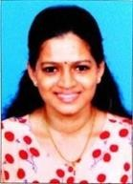
16 | Dr Preesha P. | Associate Professor | Agada Tantra evam Vidhi Vaidyaka | 1st Jan 1989 | 27/12/2024 | drpreeshap@ gmail.com 9747554215 | GBI-  24788 | AYRB 01419 | MD  Rasa Shastra & Bhaisajya Kalpana. | 6 years 3 months 9 days | 
17 | Dr. Savitha P.K | Assistant Professor | Agada Tantra evam Vidhi Vaidyaka | 13th May 1991 | 31/07/2024 | savithacontac tjiji@gmail.com 9497423526 | TCMC  16530 | AYAT 00558 | MD  Agada Tantra evam Vidhi Vaidyaka | 4 year 25 days | 
18 | Dr. Sharath V dev | Associate Professor | Panchakarma | 11th Feb  1989 | 01/05/2025 | sharathvdev@gmail.com 9446361763 | GBI-  25023 | AYPK00212 | MD. Panchakarma | 8 years 11months | 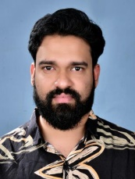
19 | Dr. Dhruvkumar P. Jani | Assistant Professor | Panchakarma | 11th Dec  1996 | 01/08/2025 | janidhruv104@gmail.com  9726894706 | GBI-  22421 | AYPK01756 | MD. Panchakarma | 6 months | 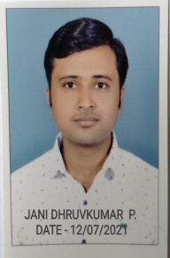
20 | Dr. Romana N. Barodiya | Assistant professor | Panchakarma | 20th Jan 1997 | 28/11/2025 | Romanabarodiya786@gmail.com  9978667431 | GBI-22468 | AYPK01690 | MD Pancha karma | 10 months | 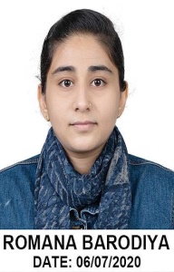
21 | Dr. Athulya K R | Associate Professor | Prasuti Tantra - Stri Roga | 13th Oct  1988 | 25/10/2024 | drathulyakr@gmail.com, 9400824848 | GB-I-  25024 | AYST00074 | Ms Ayu.Shalya Tantra | 8 years 11 months 3 days | 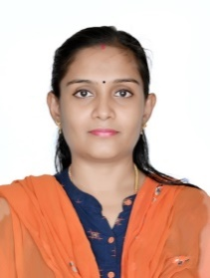
22 | Dr. Poornima Iyer | Assistant Professor | Prasuti Tantra - Stri Roga | 18thmay 1996 | 01/10/2005 | Piyer941@gmail.com  8999844395 | A-931/2024 | AYPS01609 | MS(OBGY) | 1 year/8 months/9 days | 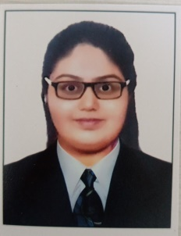
23 |  | Assistant Professor | Prasuti Tantra - Stri Rogar | 08th nov  1994 | 25/11/2025 | Misti81194@gmail.com  8690038996 | GBI-29067 | AYPS01987 | MS(OBGYN) | 2month 6 day | 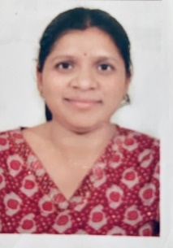
24 | Dr. Chirag Vaghela | Associate Professor | Shalya Tantra | 24-11-1993 | 30/10/2025 | Chiragvaghela178@gmail.com  8460372726 | GB-I-29049 | AYST-01839 | MS. Ayu. Shalya Tantra | 5 year 2 month 22 days | 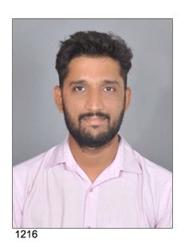
25 | Dr. Wasim I. Kazi | Assistant Professor | Shalya Tantra | 3rd  Oct  1997 | 20/05/2024 | Kaziwazim1997@gmail.com  7016583427 | GB-I  22426 | AYST02514 | MS. Ayu. Shalya Tantra | 1 year 8 month 11 days | 
26 | Dr .Vishva Patel | Assistant Professor | Shalya Tantra | 6th Feb 1998 | 1/11/2025 | Vishvapatel6298@gmail.com  7016573745 | GB-I  23414 | AYST02838 | MS. Ayu. Shalya Tantra | 3 months | 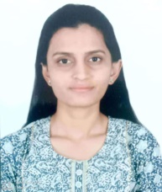
27 | Dr. Divya T N | Associate Professor | Kaumarabhritya | 25th March 1984 | 12/06/2025 | Divyatn4009@gmail.com  9446866179 | TCMC-10139 | AYKB00255 | MD. Kaumarabhritya | 7 years | 
28 | Dr. Dharaben Makwana | Associate Professor | Shalakya Tantra | 3rd August 1990 | 16/01/2026 | dharapatelddd@gmail.com  9898961826 | GB-I-19494 | AYSK00025 | M.S.(Ayu.), Ph.D.  Shalakya Tantra | 5 years 4 months | 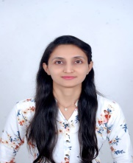
29 | Dr.Nisha Vinodbhai Ganatra | Assistant Professor | Shalakya Tantra | 26th Jan  1995 | 01/05/2025 | nishaganatra1@gmail.com  8128980524 | GBI  21457 | AYSK00940 | Ms Ayu.Shalakyatantra | 4 year 2 month | 
30 | Dr Darshanaben Himatbhai Vekariya | Assistant Professor | Shalakya Tantra | 18/12/1996 | 14/11/2025 | vekariyadarshana18@gmail.com  9737206302 | GB- I- 22505 | AYSK01255 | Ms Ayu.Shalakyatantra | 1year 10 months 18 days | 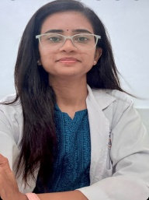
31 | Dr Nikunj Thakkar | Professor | Kayachikitsa | 03/11/1986 | 01/01/2026 | drnikunjthakkar@gmail.com  9913400524 | GB-I-25029 | AYKC00155 | MD(Ayu)  Kayachikitsa | 10 years1month 18 days | 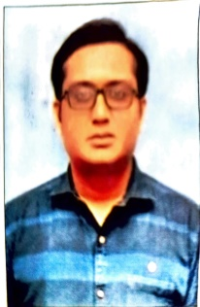
32 | Dr Babu Paul K | Associate Professor | Kayachikitsa | 21st March 1990 | 27/10/2025 | drbabupaul@gmail.com  9048381203 | TCMC - 14254 | AYKC00051 | MD;Ayu  Kayachikitsa | 6 years/9 months/6 days | 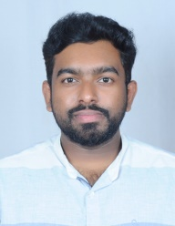
33 | Dr. Urvashi Makhesana | Assistant Professor | Kayachikitsa | 29th april 1998 | 01/05/2025 | Urvashipatel294@gmail.com  9737660241 | GBI-  23174 | AYKC04149 | MD. Kayachikitsa | 9 months | 